Production Deployment Plan
L&G Meter Firmware S00244-08.02.R66

Document Control
CR / Project Number:
Version No: | 1.1
Created On: | 29/01/2026
Last Updated: | 10/02/2026
Status: | APPROVED
Author/s: | Abel Lopez

Approval Status
Stakeholder Role | Stakeholder Name | Signature | Date
Network Intelligence Manager | Tobie DeVilliers |  | 24/02/2026
Communications Manager | Stuart Bannister | As above | 24/02/2026
Meter Asset Manager | Goutham Lingam | As above | 17/02/2026
IOT System Service Lead | Wilton Gao | As above | 16/02/2026
Market & Meter Data Manager Jac | Jack Friel | As above | 16/02/2026
Manager Communication Networks Quality | Leonard Jarillas | As above | 16/02/2026

Document Purpose
The purpose of the Deployment Plan is to specify the business and technical resources, system requirements, steps, and schedule for deployment. This document establishes the Go / No-Go criteria and the documentation requirements and gives the final approval to go ahead as planned.
Related Documents
This section will list related documents. Please note that if this document is updated these related documents may also need to be changed.
Document | Location | Relationship
Meter Firmware_TSR_R66_v0.1 | Meter Firmware_TSR_R66_v0.1.docx | TSR

Reviewers
List the relevant reviewers who are responsible for the deliverables defined in this document.
Reviewer Title | Reviewer Name | Reviewed (Yes/No)
Metering Engineer | Karl Ngo | Yes
Senior AMI Strategy Engineer | Graeme Watson | Yes
Senior Metering Engineer | Fabian Perez | Yes
AMI Communications Control Operator Network | Percy Arachchige | Yes
Communication Networks Laboratory Technician Network | Kamau Njuguna | No
Smart Grid Testing SME Network | Manoj Karla | Yes
AMI Communications Analyst | Jogy Cherian | No
Asset Engineer (Distribution Intelligence) Network | Hansi Rajapaksha Vithanage Dona | No
UIQ System Analyst Information Technology | Nelson Manio | No
Compliance & Projects Analyst | Wayne Johnson | Yes
IoT Systems Administrator | Amy Fan | Yes
Market & Meter Data Team Leader | Can Turk | Yes

Document Distribution (Information only)
Distributed to

Table of Contents
1. Introduction 4
1.1. Project Background 4
1.2. Objectives 4
1.3. Dependencies 4
2. Deployment Approach 5
2.1. Scope 5
2.2. Deployment Schedule and Stages 5
2.2.1. Deployment Schedule 5
2.2.2. Deployment Stages 7
1. Pre-analysis Stage 8
2. BVT Stage (56 Meters) 9
3. Stage 1 (100 Meters) 11
4. Stage 2 (500 meters) 12
5. Stage 3 (All meters) 14
6. BAU Stage (All remaining Meters) 16
3. Deployment Roles and Responsibilities 18
3.1. Deployment Lead 18
3.2. Go – No Go 18
3.3. Escalation 18
3.4. Stakeholder Communication 18
• Operational and Support Groups 18
4. Identified Risks 20
5. Appendix 21
5.1. FWU Progress Report 21
6. Revision 22

Introduction

Project Background
There is a new meter firmware 08.02.R66 (S00244-08.02. R66) released from L&G for U1300 meters. This firmware will be used to upgrade the production meters. This Firmware resolves some of the existing issues in previously released firmware e.g.
- Upgrade to R59 (8.1.14) is corrupting the meter program and meter data on U-Series meters.
- U1300 - FW-Load Control command -1 when issued from UIQ system is not working with R5.9 FW.
Before deploying Meter firmware to the production AMI system, it is essential to ensure that the new release poses minimal risk to business operations and meets all relevant requirements. To this end, the Communication Networks Quality Group has conducted rigorous testing to verify the firmware's functionality and performance. This document will provide a synopsis of the firmware covered and details of the results.

Objectives
- Upgrade all L+G U1300 meters both in VPN and UE

Dependencies
- Meter Firmware_TSR_R66_v1.0 – Test Summary Report

Deployment Approach

Scope
- Both UE and VPN AMI network and devices are in scope.
- Meters with the following properties will be in scope of this deployment activity.

Meter Type | NIC Variant | NIC Firmware | Meter Firmware | VPN - Count of Meters | UE - Count of Meters
U1300- 10MLx | NIC320/NIC420 | 5.4.33 | 5.5.R54 | 158,262 | 13,793
U1300-11MLx | NIC320/NIC420 | 5.4.33 | 5.5.R54 | 1,610
U1300-12MLx | NIC320/NIC420 | 5.4.33 | 5.5.R54 | 8,586
Table 1: Meter Firmware in Scope

Deployment Schedule and Stages
The upgrade shall be divided into several stages as shown in the figure below. In Pilot 1, we need to set-up 2 meters per Meter program ID so this will set up for the succeeding meters (to be upgraded) not to get stuck in initialization due to a mismatched program for the rest of the upcoming stages as the meter will transition to a new AMM Meter Program ID after the meter firmware upgrade.
Note: The mentioned deployment schedule for different stages will be followed for each of the meter type: U1300- 10MLx, U1300- 11MLx, U1300- 12MLx for the Meter Firmware separately.
    - Deployment Schedule
The proposed deployment schedule is shown in the figure below in reference to the start date of 01 of March 2026. This start date is dependent on the approval of the deployment plan (this document) and will be revised accordingly. The duration are estimates based on previous firmware upgrades and will be monitored and adjusted during the deployment activity.
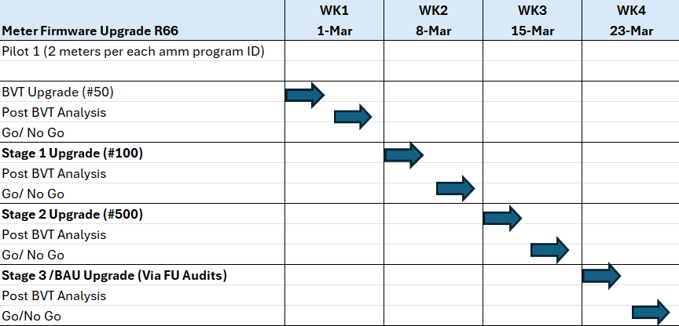
Figure 1- Deployment Schedule
    - Deployment Stages
The BVT upgrade of the meters should be carried out in well-established areas, preferably in proximity to the Burnley Depot or Brooklyn Depot.
Example: Sunshine City
The upgrade shall be divided into several stages as shown in the figure below:

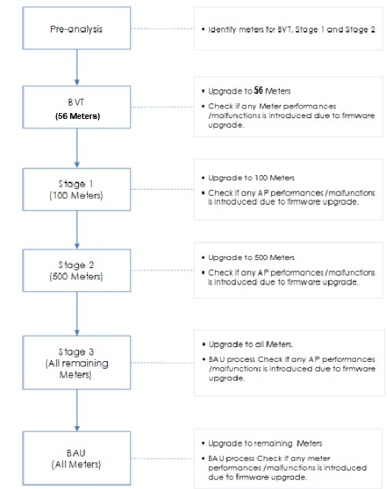
Figure 2 - Firmware deployment stages

Progress of the firmware upgrade shall be monitored through the FWU reporting tool and FWU project details.

Pre-analysis Stage

Resources Required: ACCG

The pre-analysis stage shall be composed of the following activities:
- Identify Meters with operational state “Active” and Disconnected” having good communication history and avoid using COMMS_FLAPPERS
- The meter FW upgrade activity can be performed on 2 meters for each program ID. Once the new program ID for each corresponding old program IDs are approved, then the mass meter FW upgrade shall be performed. In this case, meters will be able to move to active state once the program mismatch is accepted for those meters in bulk.
  - VPN – Meter Program IDs: 28
  - UE – Meter Program IDs: 6
- List all meters that are to be in scope of BVT, Stage 1 and Stage 2 based on the following criteria:
  - Operation state: Active
  - Location: Close proximity to Burnley depot or Brooklyn depot
  - BVT Stage: 56 Meters (U1300) Meter FW 5.5.R54
  - Stage 1: 100 Meters (U1300) Meter FW 5.5.R54
  - Stage 2: 500 Meters (U1300) Meter FW 5.5.R54
- Import list of meters BVT, Stage 1 and Stage 2 into the tracking spreadsheet located in:
  - 2025 - L&G 08.02.R66 Firmware
- Upgrade initially for only 2 meters per Program ID:
  - U1300- 10MLx L+G IEC U1300 1PH 1E HAN
  - U1300- 11MLx L+G IEC U1300 1PH 1E LC HAN
- Collect all pre upgrade data and record in the tracking spreadsheet. The pre and post firmware upgrade data shall be compared to ensure that the expected behaviour is observed.

Data to be collected | Method | Expected
Meter communication | UIQ Ping Schedule/NC/MKT | Meters have >99% comms performance
Meter Interval data Read | UIQ Schedule/NC | Meter data up to date available
Meter events | UIQ Schedule | There are no unexpected meter events generated
Meter Performance | UIQ Schedule | Hourly meter read performance as expected
AMM Program ID Pre and Post | UIQ AMM | AMM Program ID Pre upgrade must be the same AMM Program ID Post upgrade
Table 4 - Pre & Post Upgrade Data

BVT Stage (56 Meters)

Resources Required: ACCG, UIQ Support, Data Analytics, AMI Data (MDP)

During the BVT stage, a small number (56) of meters shall be upgraded and the impact of the upgrade analysed. This minimises the risk of meter malfunctions, if any, that may be introduced by the new firmware that has not been detected during testing.

Steps:
  - Create and run the FWU project for each meter type using the appropriate firmware image type. The upgrade setting for each FWU upgrade shall be as follows:
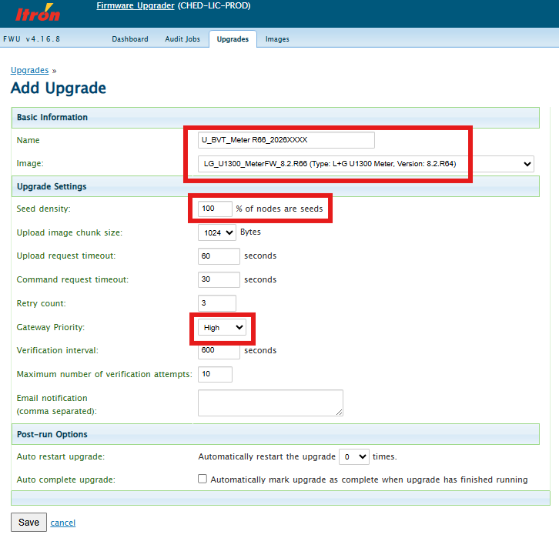
Figure 3: BVT Upgrade Set up
  - Monitor the success rate and duration of each firmware upgrade. Report any noticeable slowness in the upgrade compared to past meter firmware upgrades.
  - Collect all post upgrade data and record in the tracking spreadsheet.
  - Compare the pre and post upgrade data in the tracking spreadsheet and verify the impact of the deployment of new firmware to the Meter performance.
  - Check the AMM Program ID Pre upgrade which must be the same to the AMM Program ID Post. If it is not the same, then stop the deployment and escalate to the Communication Networks Quality Manager.
  - Check for any communications from UIQ Support, Data Analytics and AMI Data team for any major impact. If any major adverse effect is detected in this stage, stop the deployment and escalate to the Communication Networks Quality Manager. The issue will be investigated further with assistance from the following teams:
- Communication Networks Quality
- Other teams as needed
  - If all issues, if any, has been resolved, proceed to the next stage.
  - Communicate results of the BVT, and if proceeding to the next stage, to the relevant stakeholders.

Stage 1 (100 Meters)

Resources Required: ACCG, UIQ Support or Data Analytics

In Stage 1, a larger number (100) of meters shall be upgraded and the impact of the upgrade analysed.

Steps:
- Create and run the FWU project for each firmware image type. The upgrade setting for each FWU upgrade shall be as follows:
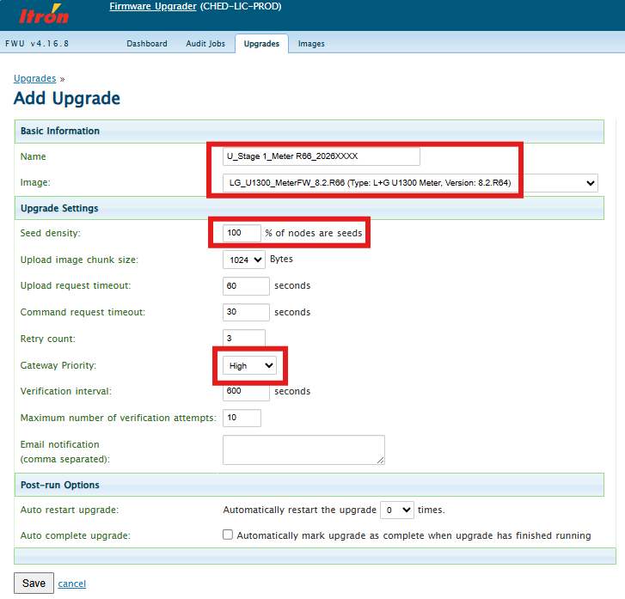
Figure 4: Stage 1 Upgrade Set up

- Monitor the success rate and duration of each firmware upgrade. Report any noticeable slowness in the upgrade compared to past meter firmware upgrades.
- Monitor for any meter failed the upgrade and send a list to the Communication Networks Quality Manager for investigation and triage.
- Collect all post upgrade data and record in the tracking spreadsheet.
- Compare the pre and post upgrade data in the tracking spreadsheet and verify the impact of the deployment of new firmware to the Meter performance.
- Check the AMM Program ID Pre upgrade which must be the same to the AMM Program ID Post. If it is not the same, then stop the deployment and escalate to the Communication Networks Quality Manager.
- Check for any communications from UIQ Support, Data Analytics and AMI Data team for any major impact. If any major effect is detected in this stage, stop the deployment and escalate to the Communication Networks Quality Manager. The issue will be investigated further with assistance from the following teams:
- Communication Networks Quality
- Other teams as needed
- If all issues, if any, has been resolved, proceed to the next stage.
- Communicate results of the Stage 1, and if proceeding to the next stage, to the relevant stakeholders.

Stage 2 (500 meters)

Resources Required: ACCG, UIQ Support or Data Analytics

In Stage 2, a significant number (500) of meters shall be upgraded and the impact of the upgrade analysed.

Steps:
- Create and run the FWU project for each firmware image type. The upgrade setting for each FWU upgrade shall be as follows:
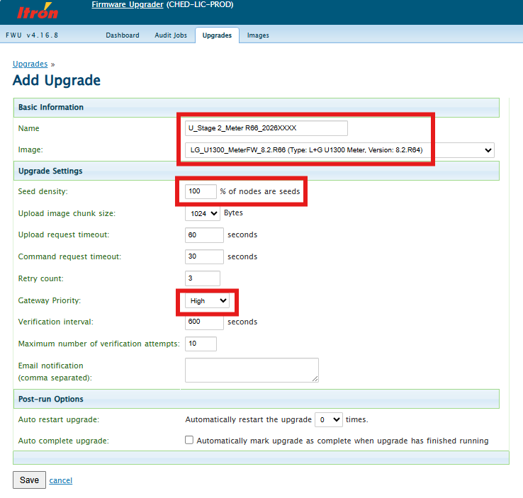
Figure 5: Stage 2 Upgrade Set up
- Monitor the success rate and duration of each firmware upgrade. Report any noticeable slowness in the upgrade compared to past meter firmware upgrades. If necessary, restart the FWU project.
- Monitor for any meter that failed the upgrade and send a list to the Communication Networks Quality Manager for investigation and triage.
- Collect all post upgrade data and record in the tracking spreadsheet.
- Check the AMM Program ID Pre upgrade which must be the same to the AMM Program ID Post. If it is not the same, then stop the deployment and escalate to the Communication Networks Quality Manager.
- Check for any communications from UIQ Support, Data Analytics and AMI Data team for any major impact. If any major effect is detected in this stage, stop the deployment and escalate to the Communication Networks Quality Manager. The issue will be investigated further with assistance from the following teams:
- Communication Networks Quality
- Other teams as needed
- If all issues, if any, has been resolved, proceed to the next stage.
- Communicate results of Stage 2, and if proceeding to the next stage, to the relevant stakeholders.

Stage 3 (All meters)

Resources Required: ACCG, UIQ Support or Data Analytics

In Stage 3, there is now high confidence that the new firmware does not pose any significant risk to the meter functionality. All the remaining meters that need to be upgraded to the new firmware will be covered in this stage.

Steps:
- Create and run the FWU project for each firmware image type. The upgrade setting for each FWU upgrade shall be as follows:
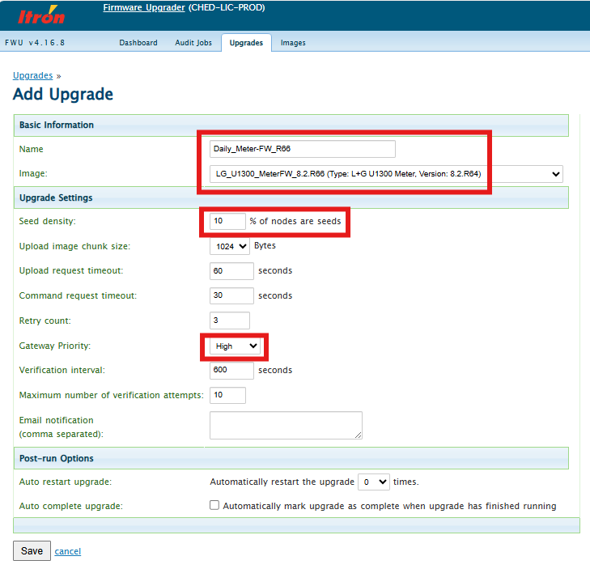
Figure 6: Stage 3 Upgrade Set up

- Monitor the success rate and duration of each firmware upgrade. Report any noticeable slowness in the upgrade compared to past meter firmware upgrades. If necessary, restart the FWU project.
- Monitor for meters that failed the upgrade and send a list to the Communication Networks Quality Manager for investigation and triage.
- Collect all post upgrade data and record in the tracking spreadsheet.
- Compare the pre and post upgrade data in the tracking spreadsheet and verify the impact of the deployment of new firmware to the meter performance.
- Check the AMM Program ID Pre upgrade which must be the same to the AMM Program ID Post. If it is not the same, then stop the deployment and escalate to the Communication Networks Quality Manager.
- Check for any communications from UIQ Support, Data Analytics and AMI Data team for any major impact. If any major effect is detected in this stage, stop the deployment and escalate to the Communication Networks Quality Manager. The issue will be investigated further with assistance from the following teams:
- Communication Networks Quality
- Other teams as needed
- If all issues, if any, has been resolved, proceed to the next stage.
- Communicate results of Stage 3, and if proceeding to the next stage, to the relevant stakeholders.

BAU Stage (All remaining Meters)

Resources Required: ACCG, UIQ Support or Data Analytics

In the BAU stage, all the remaining meters shall be targeted and upgraded to the New firmware.

Steps:
- Create the FWU audit for each NIC Architecture type. The suggested audit setting for each FWU audit shall be as follows:
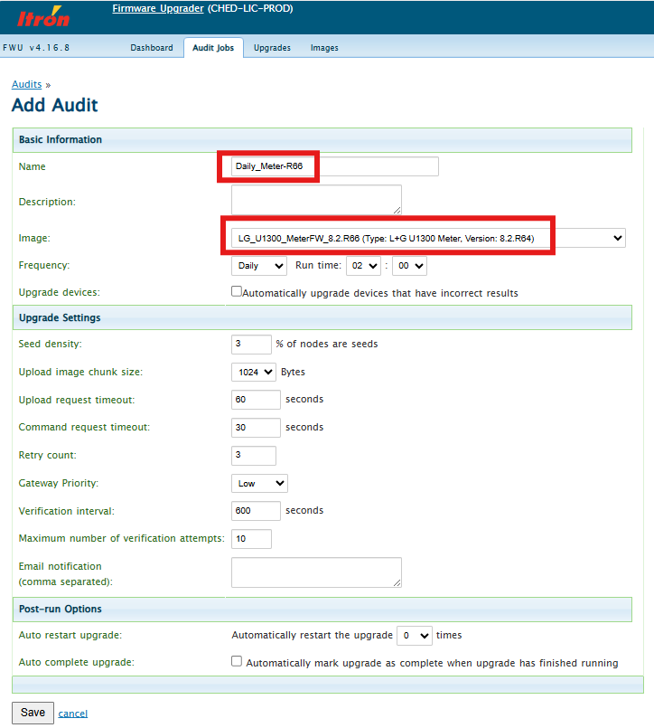
Figure 7: BAU Stage Set up

- Notify relevant stakeholders prior to commencement of the audit and automatic upgrade. UIQ Support team will need to monitor the backend system and UIQ application during the upgrade.
- Monitor the success rate and duration of each automatic firmware upgrade daily. Report any noticeable slowness in the upgrade compared to past meter firmware upgrades. If necessary, restart the FWU project.
- Continue to monitor the events and look for any critical events, not limited to those listed below.
- Check the AMM Program ID Pre upgrade which must be the same to the AMM Program ID Post. If it is not the same, then stop the deployment and escalate to the Communication Networks Quality Manager.
- Check for any communications from UIQ Support, Data Analytics and AMI Data team for any major impact. If any major effect is detected in this stage, stop the deployment and escalate to the Communication Networks Quality Manager. The issue will be investigated further with assistance from the following teams:
- Communication Networks Quality
- Other teams as needed
- Continue to monitor the upgrade success rate, critical events.
- Communicate firmware upgrade progress and any issues to relevant stakeholders.

Deployment Roles and Responsibilities

Deployment Lead
The deployment leads for the new Meter firmware are:
- VPN/UE: Percy Arachchige/Abel Lopez

Go – No Go
Each stage will have a go-no go checkpoint with the following stakeholders as approvers:

Deployment Stage | Role | Stakeholder
Stage 1  Stage 2 | Metering Engineer • United Energy | Karl Ngo
 | Senior AMI Strategy Engineer • United Energy | Graeme Watson
 | AMI Communications Analyst • Network | Sangsukdee, Wayne
 | Communication Networks Laboratory Techni • Network | Njuguna, Kamau
 | AMI Communications Analyst • United Energy | Cherian, Jogy
Stage 3
BAU Upgrade
 | Communications Manager | Stuart Bannister
 | Meter Asset Manager | Goutham Lingam
 | IOT System Service Lead | Wilton Gao
 | Market & Meter Data Manager Jac | Jack Friel
 | Manager Communication Networks Quality | Leonard Jarillas

Escalation
The first point of escalation will be the Communication Networks Quality Manager and depending on the issue, he/she will contact the relevant stakeholders in the reviewer’s list.

Stakeholder Communication
The stakeholders in the reviewer and approver list shall be notified of the progress and any issue found during the firmware upgrade deployment. The mode of communication shall be via email.

Operational and Support Groups
- ACCG
  - Overall firmware upgrade process
  - Send progress report
- UIQ Support
  - General UIQ application support and monitoring
  - Support on data requests that cannot be easily retrieved from the UI
- Data Analytics
  - SIQ and PQ polling data monitoring
  - Support on data requests that cannot be easily retrieved from the UI
- AMI Data (MDP)
  - AMI data to market monitoring

Identified Risks

Ref | Description | Details | Mitigation
Risk#1 | Firmware downgrade not supported | Once upgraded to the new 08.02.R66 firmware, the meter will not be able to go back to the non-MS firmware. | Critical tests have been done during testing.  Staged deployment of the meter firmware.
Risk#2 | Accidental disabling of boost primacy | When a boost primacy enable command is sent to a meter that already has boost primacy enabled, the boost primacy will permanently get disabled. | Program the meter to re-enable boost primacy.
Risk#3 | Cancellation of Priority override command due to Meter upgrade | If the meter firmware upgrade is performed while priority override command is being executed for the given duration. Once the meter is upgraded successfully meter reboots and the priority override command is cancelled for the remaining duration. The Auxiliary switch attains the default state as per the schedule. | Avoid the meter firmware upgrade when priority override commands (e.g. broadcast command for hot water load) are to be executed.
Risk#4 | Challenge to bring the meters to active state after the FW upgrade | When the meter FW is upgraded to R66, the program ID of the meter is changed. This brings the meter to initialize state. The program needs to be approved to bring the meter to active state. | The meter FW upgrade activity can be performed on one meter for each program ID. Once the new program ID for each corresponding old program IDs are approved, then the mass meter FW upgrade shall be performed. In this case meters will be able to move to active state once the program mismatch is accepted for those meters in bulk.
Risk#5 | AMM Program ID Pre upgrade is not the same to the AMM Program ID Post upgrade | When the meter is upgraded to R66, the program ID of the meter is changed and should only be the same on Pre and Post upgrade else upgrade needs to be stopped. | Monitor/Check during each stage and do not proceed when AMM ID Program result condition does not met.

Appendix
Include exports from ALM for the execution results and defects.

FWU Progress Report
The following information shall be sent as part of the daily FWU progress report.

Issue# | Summary | Status

Project Name | Start | Stop | Total Devices | Succeeded | Failed | % completed

Revision
Version | Date | Updated by | Comments
0.1 | 29/01/2026 | AL | Draft
1 | 04/02/2026 | AL | Added the checks on AMM Program ID Pre counts and Post counts on Upgrade
1.1 | 10/02/2026 | AL | Minor revisions on the tables and instructions

